|  |  |  |  |  |  |  |  |
| --- | --- | --- | --- | --- | --- | --- | --- |
| Test Case ID | Use case ref | **Description of Test** | **Test Initialisation** | **Test Inputs** | **Test Procedure** | **Expected Results** | **Passed?** |
| tM001 | ucM01 | **User can select each menu item.** | **Game must be in main menu or submenu.** | **Arrow keys.** | **The user must select each menu item using the up and down arrow keys.** | **The next menu item should be highlighted.** |  |
| tM002 | ucM02 | **User can make a selection on the menu.** | **Game must be in main menu or submenu.** | **Arrow keys and space bar.** | **They must then press the space bar to confirm the choice.** | **The game should launch the module relevant to the user’s selection.** |  |
| tM002 | ucM03 | **User can return from submenus** | **Game must be in submenu.** | **Arrow keys and space bar.** | **The user selects the “Return” or similar menu item and then must press the space bar to select it.** | **The user is returned to the main menu.** |  |
| tM003 | ucM03 | **User can use shortcut to return from submenus** | **Game must be in submenu.** | **Escape key.** | **The user presses the escape key.** | **The user is returned to the main menu.** |  |
| tM004 | ucM04 | **User can change settings via menu items.** | **Game must be in options submenu.** | **Arrow keys and space bar.** | **The user selects the setting they want to change and presses the space bar to cycle through the options.** | **The change should not reset once the user exits the menu.** |  |
| tM005 | N/A | **Main menu displays icon related to selected menu entry** | **Game must be in main menu.** | **Arrow keys** | **The user moves down the menu entries.** | **Each time the selection changes, the icon should change to a corresponding image.** |  |
| tM001 | ucM01 | **User can select each menu item.** | **Game must be in main menu or submenu.** | **Arrow keys.** | **The user must select each menu item using the up and down arrow keys.** | **The next menu item should be highlighted.** |  |

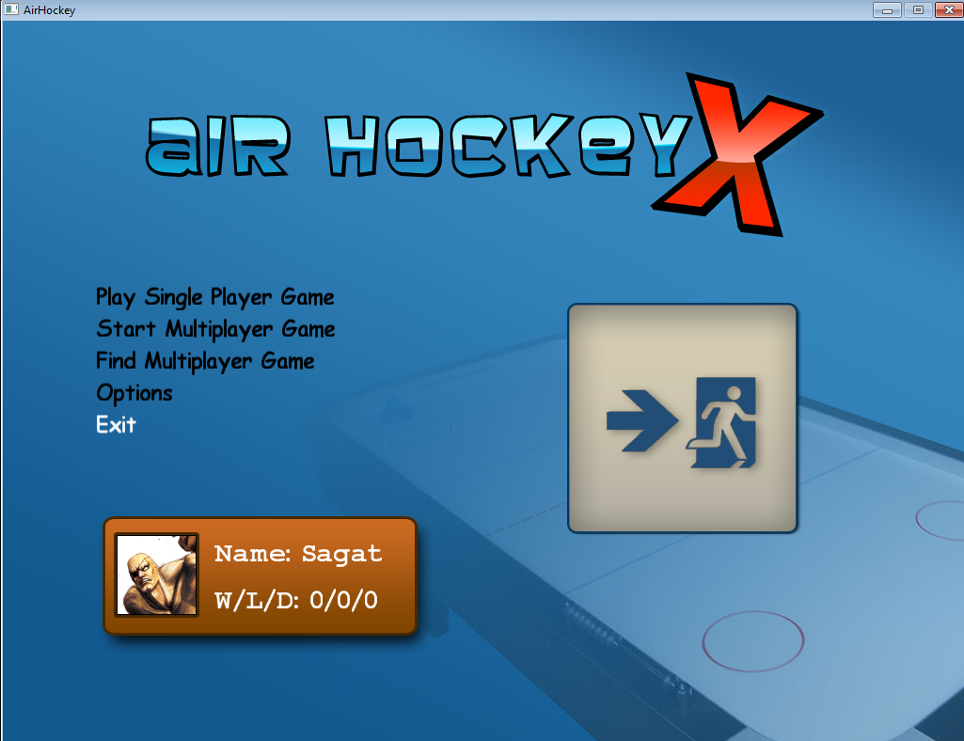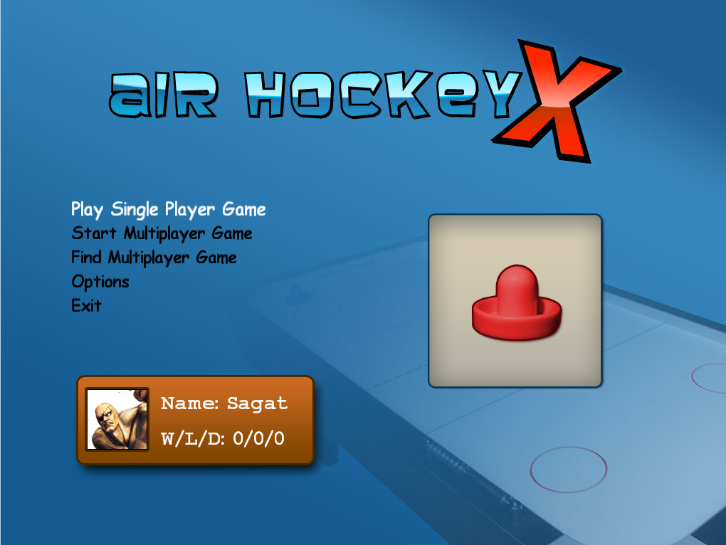

Here I have been able to move from the first menu item to the very last one by pressing the “down” arrow key, successfully highlighting each one in between.

Pressing the “up” arrow key on the first menu item will instead jump to the bottom menu item.

|  |  |  |  |  |  |  |  |
| --- | --- | --- | --- | --- | --- | --- | --- |
| tM002 | ucM02 | **User can make a selection on the menu.** | **Game must be in main menu or submenu.** | **Arrow keys and space bar.** | **They must then press the space bar to confirm the choice.** | **The game should launch the module relevant to the user’s selection.** |  |

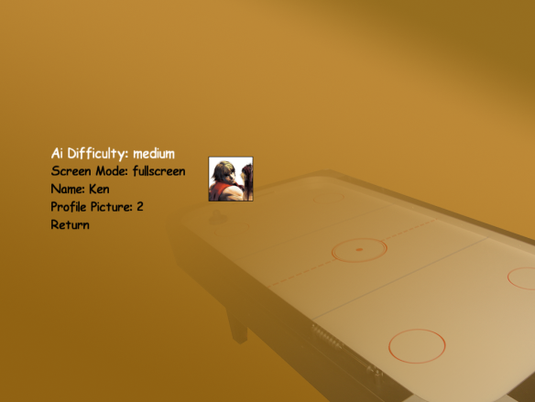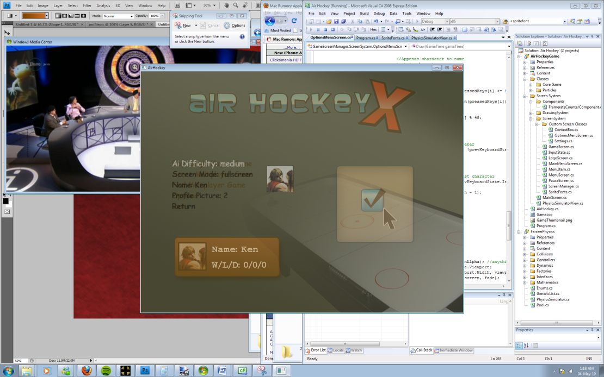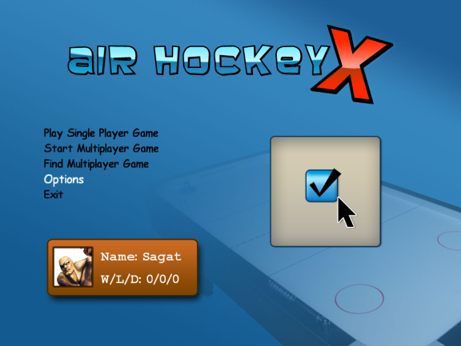

Here I have been able to select the “Options” menu entry. Upon confirming the menu choice by pressing the “space” bar or “enter”, the screen manager to loads and runs the options menu screen.

|  |  |  |  |  |  |  |  |
| --- | --- | --- | --- | --- | --- | --- | --- |
| tM002 | ucM03 | **User can return from submenus** | **Game must be in submenu.** | **Arrow keys and space bar.** | **The user selects the “Return” or similar menu item and then must press the space bar to select it.** | **The user is returned to the main menu.** |  |

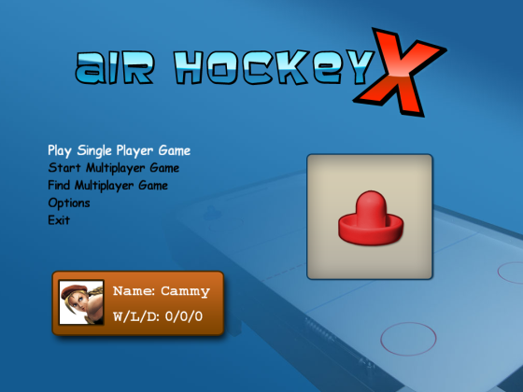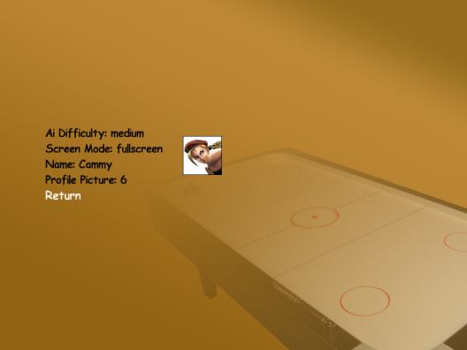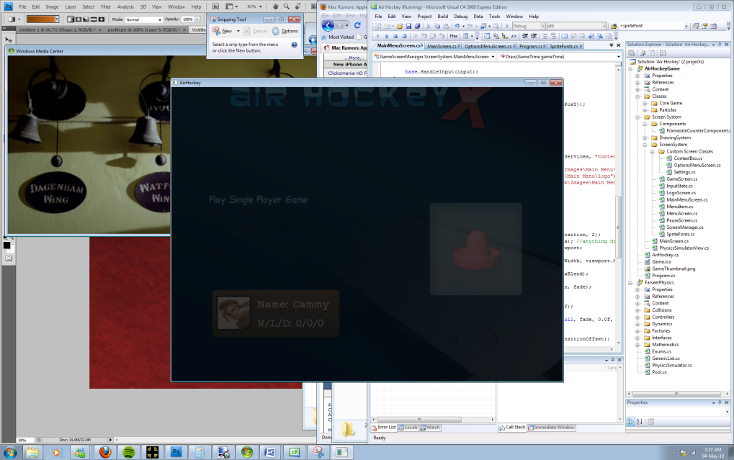

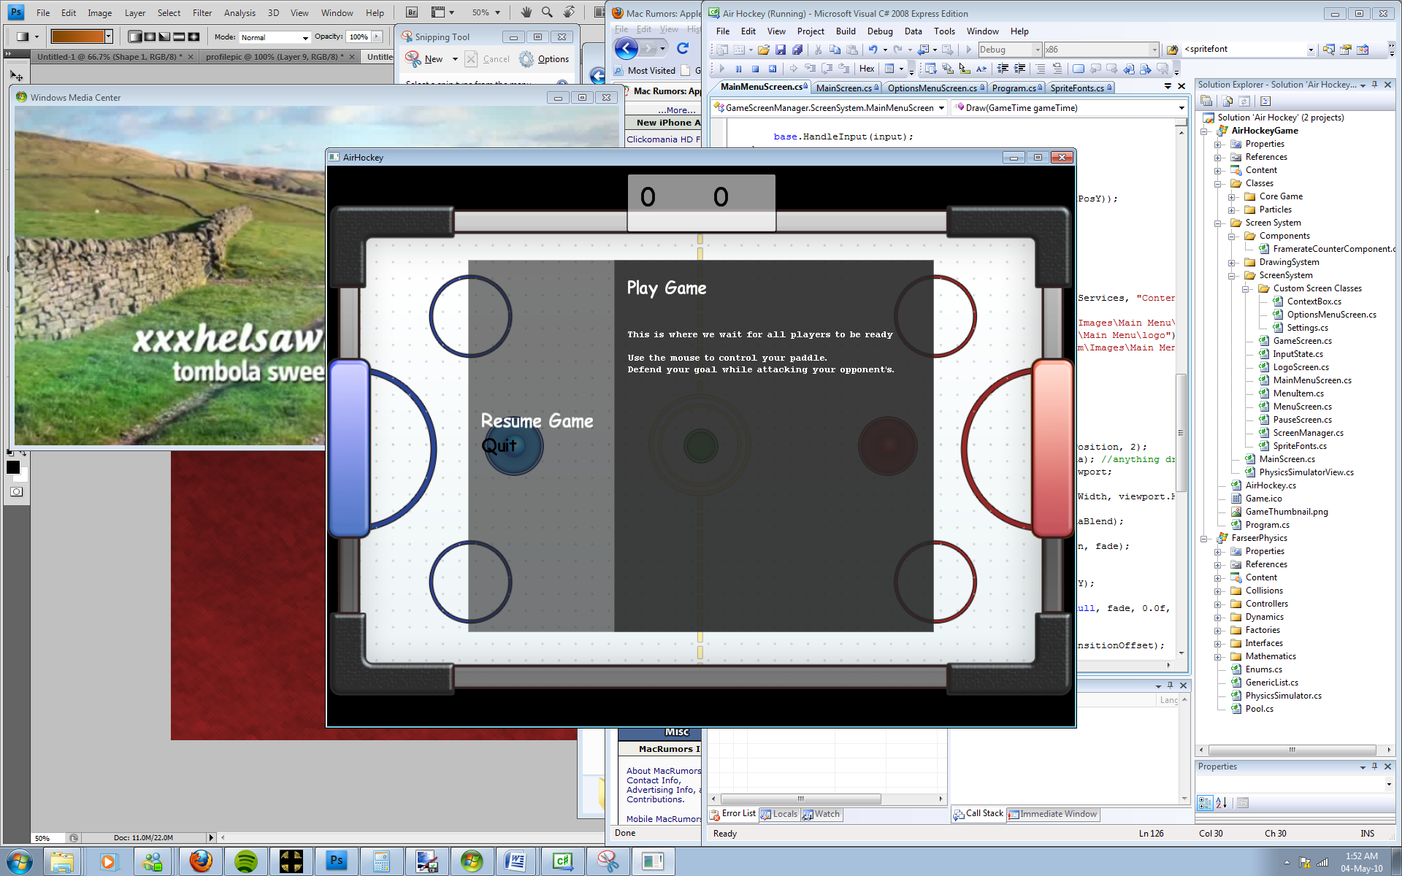In the options menu, I have selected the “Return” menu entry and have been returned to the main menu.

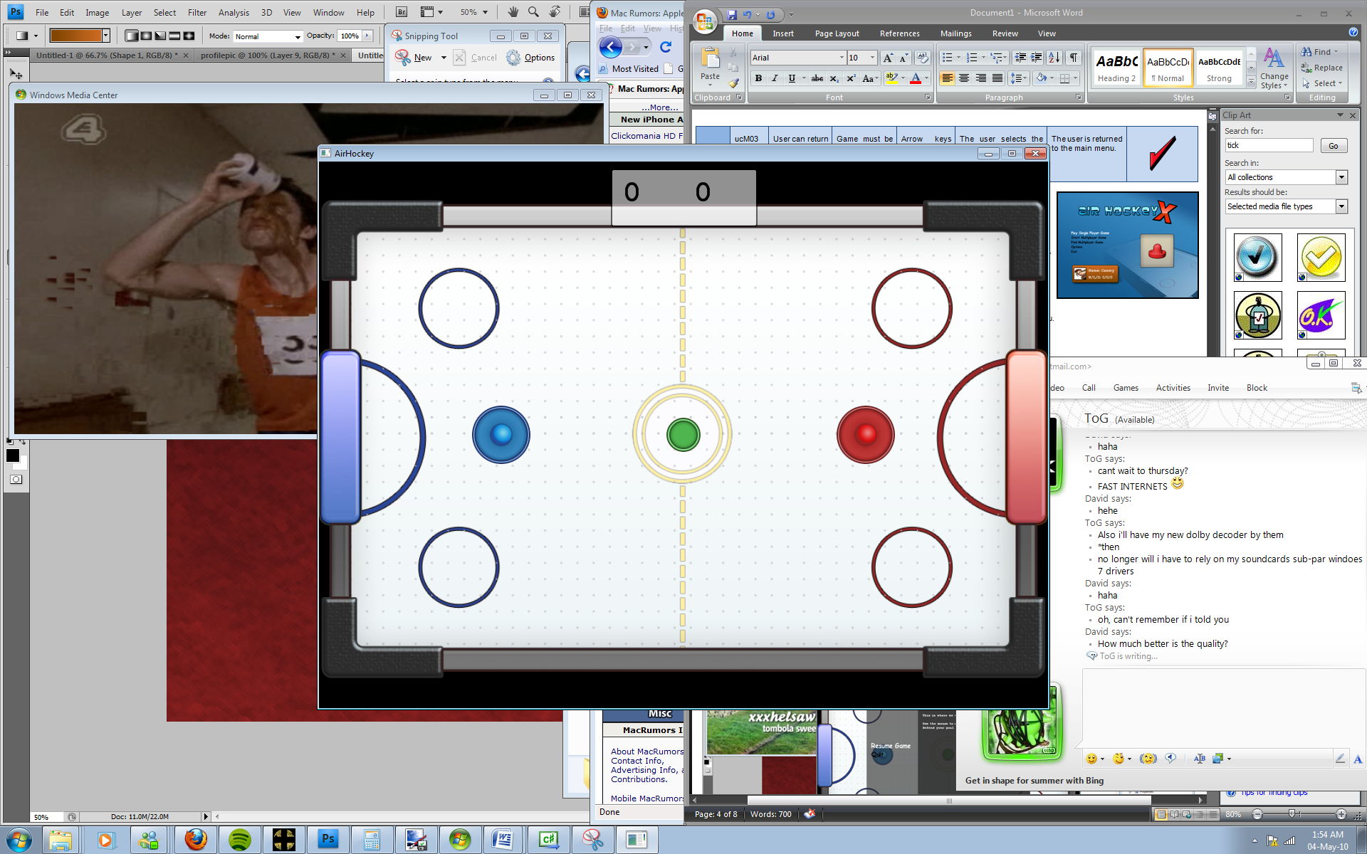On the pause screen, I can select “Resume Game” to continue:

|  |  |  |  |  |  |  |  |
| --- | --- | --- | --- | --- | --- | --- | --- |
| tM003 | ucM03 | **User can use shortcut to return from submenus** | **Game must be in submenu.** | **Escape key.** | **The user presses the escape key.** | **The user is returned to the main menu.** |  |

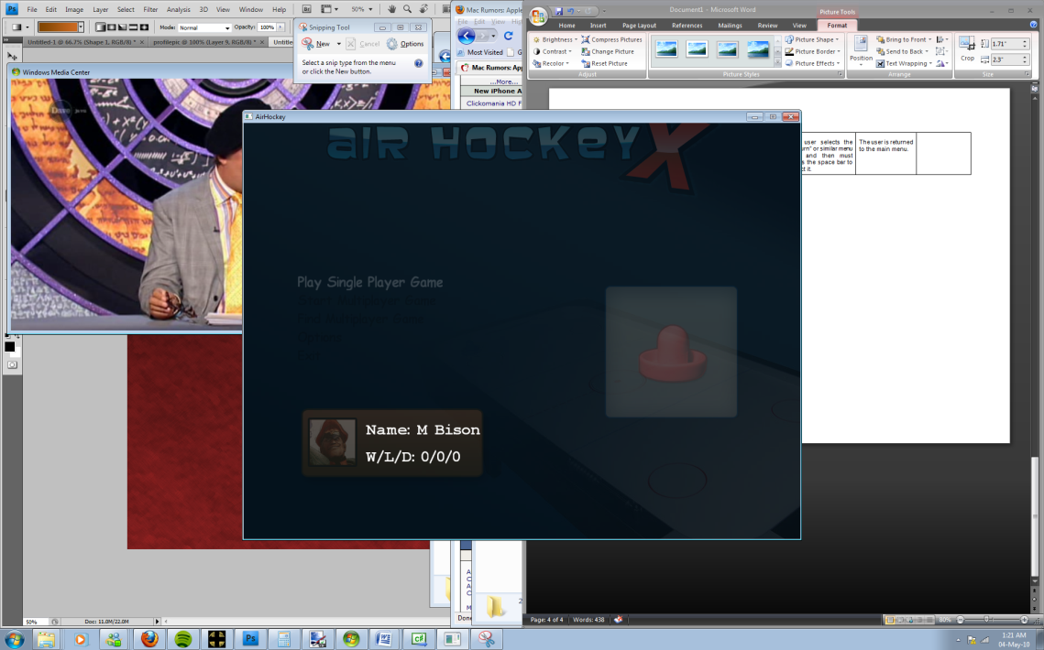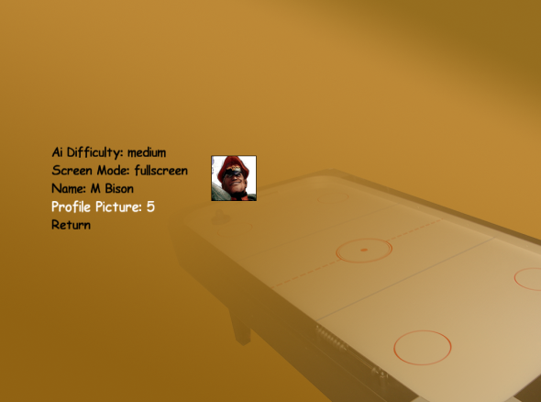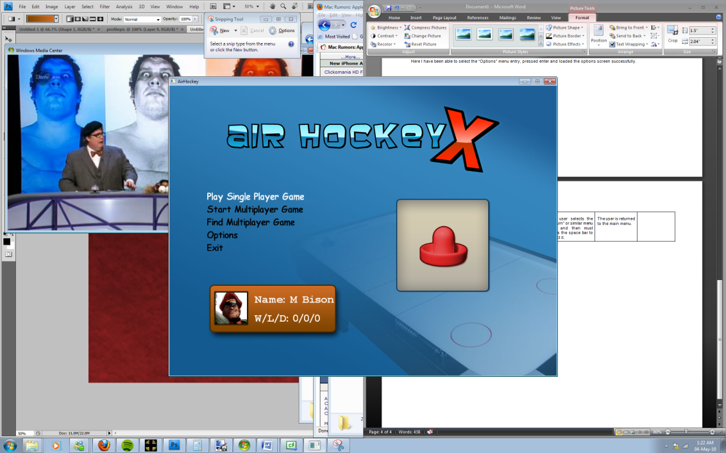

Here, in the options menu, I am able to press the “Escape” key and return to the main menu. The screen system acts in the same way as if the “return” menu option was selected.

|  |  |  |  |  |  |  |  |
| --- | --- | --- | --- | --- | --- | --- | --- |
| tM004 | ucM04 | **User can change settings via menu items.** | **Game must be in options submenu.** | **Arrow keys and space bar.** | **The user selects the setting they want to change and presses the space bar to cycle through the options.** | **The change should not reset once the user exits the menu.** |  |

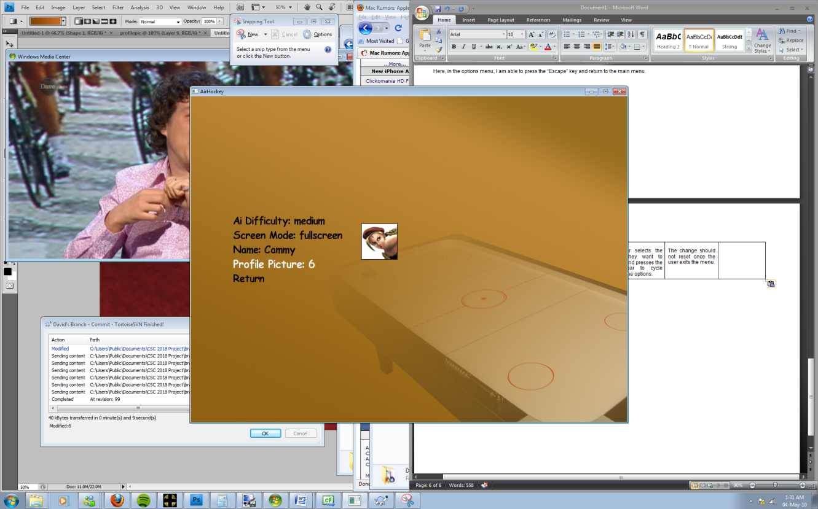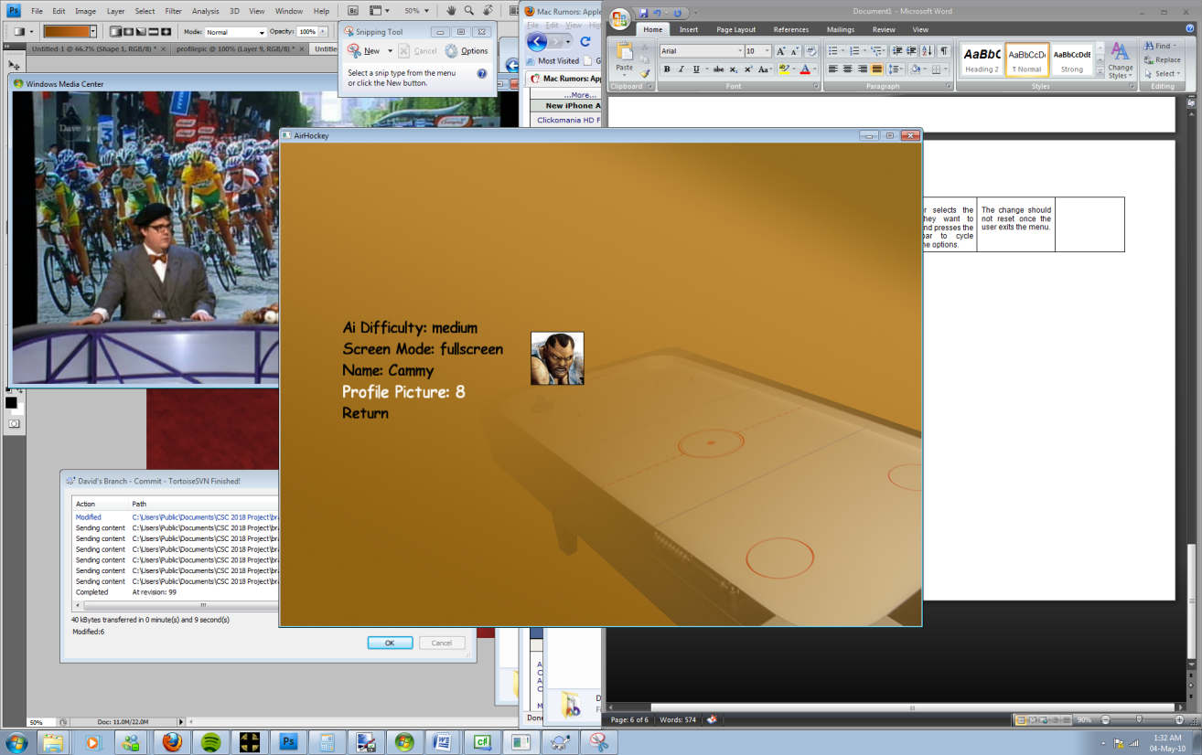

By pressing the space bar, I can cycle through the options such as the profile picture. Here I have pressed “space” twice and so the profile icon is now displaying the eighth picture.

Here I have selected the “Name” menu entry and have typed a new one. This is then reflected wherever else the profile is displayed:

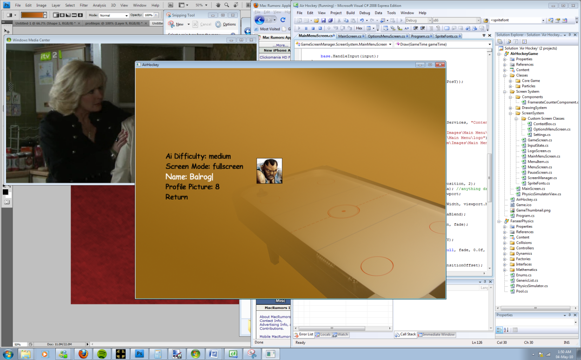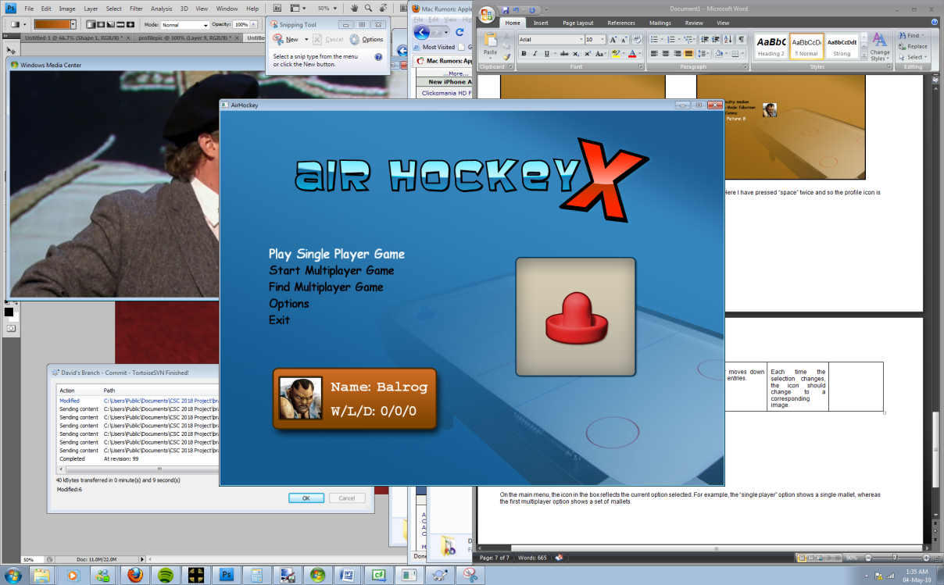

|  |  |  |  |  |  |  |  |
| --- | --- | --- | --- | --- | --- | --- | --- |
| tM005 | N/A | **Main menu displays icon related to selected menu entry** | **Game must be in main menu.** | **Arrow keys** | **The user moves down the menu entries.** | **Each time the selection changes, the icon should change to a corresponding image.** |  |

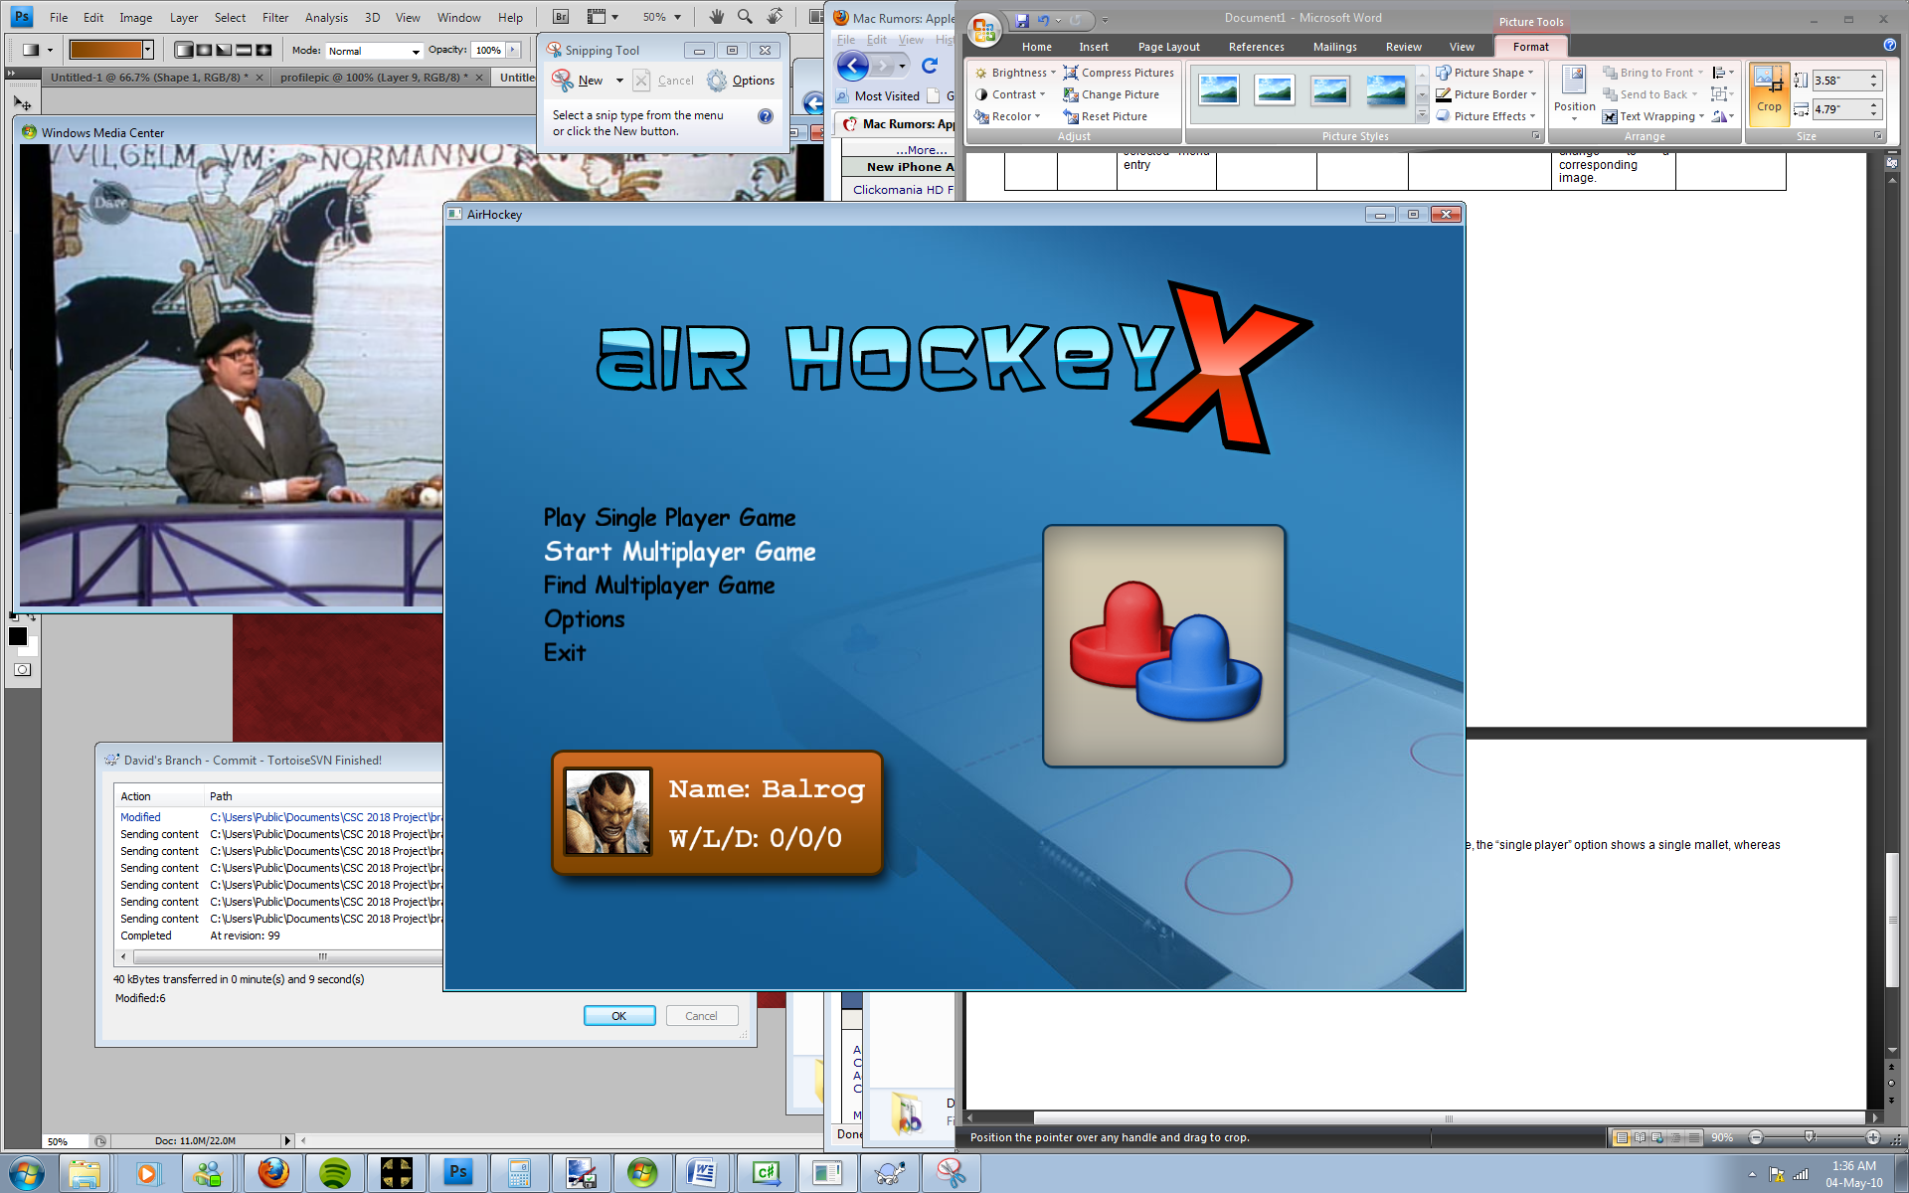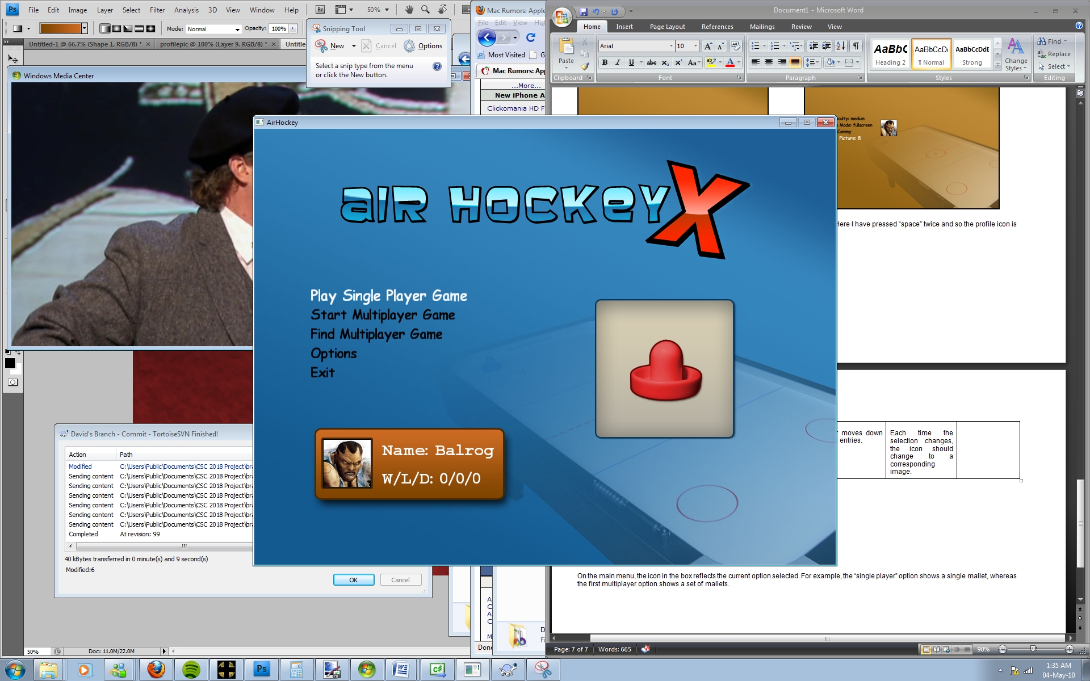

On the main menu, the icon in the box reflects the current option selected. For example, the “single player” option shows a single mallet, whereas the first multiplayer option shows a set of mallets.